INTERNATIONAL ETCHELLS CLASS
2026 Lake Champlain Regatta
Hosted by Lake Champlain Yacht Club
Organized by Etchells Fleet #25 (OA)
2790 Shelburne Road, Shelburne, Vermont, 05482 USA
26-28 June 2026
NOTICE OF RACE
POSTED 21 March 2026

Except for breaking a rule of Part 2, or rules 2, 28 or 31, the notation [DP] in a rule in the NOR means that the penalty for a breach of that rule may, at the discretion of the Protest Committee, be less than disqualification. The notation [NP] in a rule means that a boat may not protest another boat for breaking this rule. This changes rule 60.1.a.

- RULES

  - The event is governed by the rules as defined in The Racing Rules of Sailing (RRS).
    - US Sailing prescription Appendix V – Alternative Penalties will apply as described below in paragraph 13, Penalty System.
    - The RRS changes will be described in the sailing instructions. The sailing instructions may also change other racing rules.

  - [DP] International Etchells Association Class Rules will apply.

    - Any IECA Class Rule changes will be described in the sailing instructions. The sailing instructions may also change other IECA Class Rules.
    - For the purposes of Class Rule C.10.2.(b), not more than 1 mainsail, 2 headsails and 2 spinnakers shall be used during the event.

  - [DP] Bow numbers will be assigned by the Organizing Authority (OA) and supplied and fixed to each participating boat prior to first Warning on Saturday, 27 June 2026. They shall be affixed to the hull according to the instructions provided by the OA and shall be retained on both sides of the hull throughout the regatta. Boats failing to follow these requirements are subject to protest only by the Race Committee (RC).

  - Where a boat is using sails with a different sail number than that of the boat’s hull, the person in charge will inform the OA before commencement of racing. All sails being used must display the same sail number.

  - If, through no fault of its personnel, a boat’s hull, spar or sail is rendered incapable of continuing the series, the person in charge may petition, in writing, the Principle Race Officer for permission to substitute a replacement hull or spar or sail for the remainder of the series.

  - This event will be conducted in accordance with the Etchells Class Code of Conduct which is available on the IECA website (https://etchells.org/assets/documents/Code_of_Conduct_Approved_2023.07.25.pdf).

  - If there is a conflict between a rule on the Notice of Racing and a rule on the Sailing Instructions, the rule on the Sailing Instruction will take precedence. This changes RRS 63.5(c)(2).

- SAILING INSTRUCTIONS

  - The Sailing Instructions will be available no later than 16:00 on 26 June 2026 at LCYC message board.

  - The sailing instructions will consist of the instructions in RRS Appendix S, Standard Sailing Instructions, and supplementary sailing instructions that will be on the official notice board located at Lake Champlain Yacht Club.

- COMMUNICATION

  - The online official notice board is located at Lake Champlain Yacht Club, 2670 Harbor Road, Shelburne, VT. The Notice Board is on the north side of the club near the steward office.

  - [DP] All boats shall carry a working VHF radio.

  - On the water, the RC will make courtesy broadcasts to competitors on VHF radio. Failure to receive any such broadcasts will not be subject to an application for redress. This changes RRS 61.1(a). The VHF channel will be stated in the Sailing Instructions.

  - [DP] While racing, except in an emergency, a boat shall not make voice or data transmissions and shall not receive voice or data communication that is not available to all boats.

- ELIGIBILITY AND ENTRY

  - The event is open to all boats of the Etchells Class with a valid measurement certificate.
  - Boats may enter the event by registering online at: https://yachtscoring.com/event_registration_email/50753

  - To be considered an entry in the event, a boat shall complete all registration requirements and pay all fees prior to 18:00 on Friday, 26 June 2026.

  - There will be no weigh-in for this event. Crews are expected to abide by Class Rule C2.2.

- FEES

  - The Entry fees of $125 shall be paid in accordance with the online entry systems

  - The registration fee includes launch/haul, guest berthing at LCYC for visiting boats, and all regatta activities to include three Saturday dinner tickets. Additional dinner tickets will be available upon request at a price of $25/ticket.

    - Launch/Haul services will be provided by Safe Harbor Shelburne Shipyard ( Safe Harbor Shelburne Shipyard - Safe Harbor Marinas ) at 4584 Harbor Road, Shelburne, VT 05482. Trailer parking at the Shipyard is available.
    - Berthing will be on the LCYC main dock. Some guest moorings may be available upon request. LCYC does offer complimentary launch service within mooring field.
- CREW LIMITATIONS
  - The person in charge shall be an Owner IECA class member.

- SCHEDULE

  - Friday, June 26
13:00-18:00 Launch at Safe Harbor Shelburne Shipyard
After launch - Tow to LCYC
Check In & Informal social gathering at 6:00 pm
  - Saturday, June 27
08:00-09:00 Competitor check-in at LCYC
09:00 Competitor’s brieﬁng
10:55 First warning signal
18:00 Competitor’s dinner at LCYC
  - Sunday, June 28
10:55 First warning signal
14:30 No warning signal after this time
After racing Haul-out and awards at Safe Harbor Shelburne Shipyard

- EQUIPMENT INSPECTION
  - Presentation of a valid hull certiﬁcate and sail card for the boat will not be required for this event. Boat owners/persons in charge are reminded that a boat shall comply with RRS 78.1

  - There will be no crew weigh-in for this event

- VENUE

  - The Lake Champlain Etchells Regatta will be hosted by the Lake Champlain Yacht Club located at 2790 Harbor Road, Shelburne, VT 05482.

  - Attachment A shows the location of the racing areas.

- COURSES
  - The courses will be a windward / leeward configuration as described in the Sailing Instructions.
- PENALTY SYSTEM
  - The first two sentences of RRS 44.1 are changed to: “A boat may take a One-Turn Penalty when she may have broken one or more rules of Part 2 or RRS 31 in an incident while racing. However, when she may have broken one or more rules of Part 2 while in the zone around a mark other than a starting mark, her penalty shall be a Two-Turns Penalty.”
  - In RRS 44.2 insert after the first sentence: "However, if Mark 1a (spreader mark) is set, a boat may take a penalty for an incident in the zone around Mark 1 or on the leg between Mark 1 and Mark 1a, as soon as possible after leaving the zone around Mark 1a.”

- SCORING

  - Six (6) races are scheduled.

  - One (1) race is required to be completed to constitute a series.

  - When five (5) races have been completed, a boat’s series score will be the total of her race scores excluding her worst score.

  - The Fleet 25 competitors will also be scored for their Fleet 25 results from this event and these scores will be used for LCYC Fleet 25 Etchells E-3 event within the LCYC Keleman Trophy scoring.

- SUPPORT PERSON VESSELS

  - [DP] Team leaders, coaches, other support personnel and their coach and support vessels shall stay outside areas where boats are racing from the time of the first Warning Signal of the day until racing has been concluded for the day. Between races, coach and support vessels shall not approach, communicate with, nor transfer provisions or equipment to or from their supported boats, unless in a medical or emergency requirement, threatening the health of the crew or the flotation of the boat, and only with the expressed permission of the Race Committee.
  - All coach and support boats shall have a working marine VHF radio onboard and actively monitor the race committee channel and assist the race committee in matters of safety as requested.

  - Support vessels shall be marked with LCYC burgee or identifying flag/pennant as provided by the OA.

- HAUL-OUT RESTRICTIONS

  - [DP] Boats shall not be hauled out during the event except with and according to the terms of prior written permission of the race committee.
- MEDIA RIGHTS AND DATA PROTECTION

  - By participating in this event, competitors automatically grant to the OA and the event sponsors the right, in perpetuity, to make, use, and show, at their discretion, any photography, audio and video recordings, and other reproductions of them made at the venue or on the water from the time of their arrival at the venue, until their final departure, without compensation.

- RISK STATEMENT

  - RRS 3 states: ‘The responsibility for a boat’s decision to participate in a race or to continue to race is hers alone.’ By participating in this event each competitor agrees and acknowledges that sailing is a potentially dangerous activity with inherent risks. These risks include strong winds and rough seas, sudden changes in weather, failure of equipment, boat handling errors, poor seamanship by other boats, loss of balance on an unstable platform and fatigue resulting in increased risk of injury. Inherent in the sport of sailing is the risk of permanent, catastrophic injury or death by drowning, trauma, hypothermia or other causes.

- INSURANCE

  - Each participating boat shall be insured with valid third-party liability insurance with a minimum cover of $300,000 ($US) per incident or the equivalent.

  - Support vessel drivers shall have valid third-party liability insurance or the equivalent and provide proof upon request by the RC/OA.

  - Each entry shall provide proof of insurance to the Organizing Authority. Documentation shall be provided at check-in or sent to Kevin Hawko, Fleet 25, at krhawko@gmail.com

- PRIZES

  - Prizes will be given for First (1st), Second (2nd) and Third (3rd) place finishes for the series

- Event Contacts and Information

  - LCYC Regatta Chair: Kevin Hawko
Email: krhawko@gmail.com
Mobile: +1 802 373 8576

  - Fleet 25 Captain: James Unsworth
Email: junsworth100@gmail.com
Mobile: +1 802 578 7206

ATTACHMENT A – RACE AREA
Race Area 1 – Burlington Bay
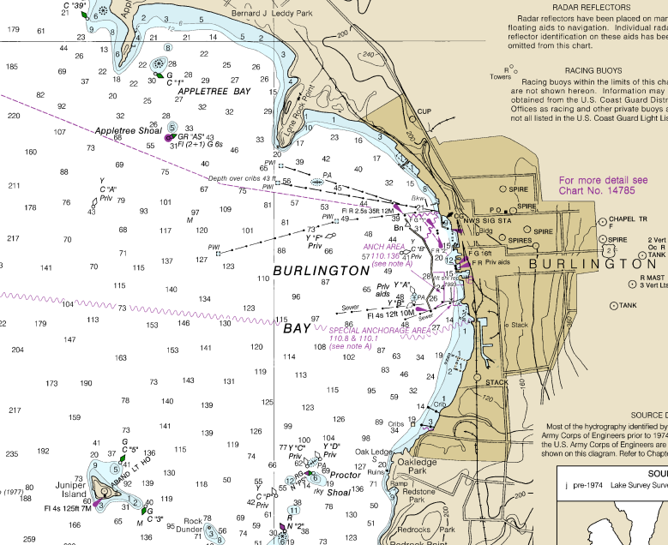

Race Area 2 – Shelburne Bay
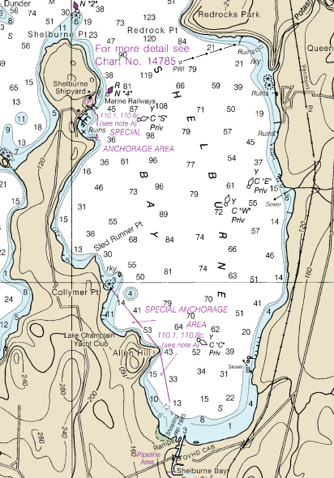

Race Area 3 – Juniper Island to Saxton Reef
